Name – Aditya Nayak

Reg Number – 21BCE0540

Number - +918976416016

Assignment 1 – username password with login button

MainActivity.kt code

package com.example.assignment1  
import android.os.Bundle  
import androidx.activity.ComponentActivity  
import androidx.activity.compose.setContent  
import androidx.compose.foundation.layout.Arrangement  
import androidx.compose.foundation.layout.Column  
import androidx.compose.foundation.layout.fillMaxSize  
import androidx.compose.foundation.layout.padding  
import androidx.compose.material3.Button  
import androidx.compose.material3.ExperimentalMaterial3Api  
import androidx.compose.material3.Text  
import androidx.compose.material3.TextField  
import androidx.compose.runtime.Composable  
import androidx.compose.runtime.getValue  
import androidx.compose.runtime.mutableStateOf  
import androidx.compose.runtime.remember  
import androidx.compose.runtime.setValue  
import androidx.compose.ui.Alignment  
import androidx.compose.ui.Modifier  
import androidx.compose.ui.graphics.Color  
import androidx.compose.ui.graphics.*RectangleShape*import androidx.compose.ui.text.TextStyle  
import androidx.compose.ui.tooling.preview.Preview  
import androidx.compose.ui.unit.dp  
class MainActivity : ComponentActivity() {  
 override fun onCreate(savedInstanceState: Bundle?) {  
 super.onCreate(savedInstanceState)  
 *setContent* **{** Column(modifier = Modifier.*fillMaxSize*(),  
 horizontalAlignment = Alignment.CenterHorizontally) **{** SimpleText()  
 SimpleTextField()  
 SimpleTextFieldpswrd()  
 Column (modifier =  
 Modifier.*fillMaxSize*(1f) ,verticalArrangement = Arrangement.Center,  
 horizontalAlignment = Alignment.CenterHorizontally) **{** SimpleButton()  
 **}  
 } }** } }  
@Composable  
fun SimpleText(){  
 Text(text = "USER LOGIN", modifier = Modifier.*padding*(50.*dp*),  
 style = TextStyle.Default  
 ) }  
@OptIn(ExperimentalMaterial3Api::class)  
@Composable  
fun SimpleTextField(){  
 var text by remember **{** *mutableStateOf*("") **}** TextField(value = text , onValueChange = **{**it **->** text = it **}**,  
 textStyle = TextStyle(color = Color.Black), label = **{** Text(text =  
 "USERNAME")**}** )  
}  
@OptIn(ExperimentalMaterial3Api::class)  
@Composable  
fun SimpleTextFieldpswrd(){  
 var text by remember **{** *mutableStateOf*("") **}** TextField(value = text , onValueChange = **{**it **->** text = it **}**,  
 textStyle = TextStyle(color = Color.Black), label = **{** Text(text =  
 "PASSWORD")**}** )  
}  
@Composable  
fun SimpleButton(){  
 Button(modifier = Modifier.*padding*(16.*dp*), onClick = **{** /\**TODO*\*/ **}**, shape = *RectangleShape*) **{** Text(text = "LOGIN")  
 **}**}  
@Preview  
@Composable  
fun SimpleTextPreview(){  
 Column(modifier = Modifier.*fillMaxSize*(), horizontalAlignment =  
 Alignment.CenterHorizontally) **{** SimpleText()  
 SimpleTextField()  
 SimpleTextFieldpswrd()  
 Column (modifier =  
 Modifier.*fillMaxSize*(1f) ,verticalArrangement = Arrangement.Center,  
 horizontalAlignment = Alignment.CenterHorizontally) **{** SimpleButton()  
  
 **} }**}

Output Screenshots

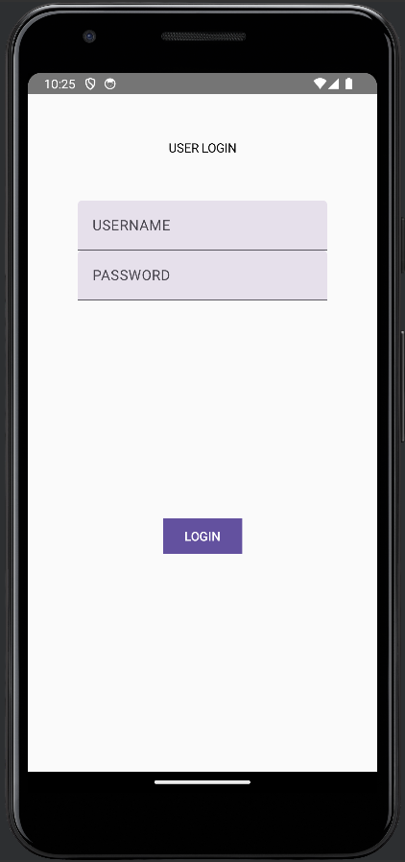

Drive link - <https://drive.google.com/drive/folders/1T2XdUZx_1iMoCgUJsz1RrbdcqUF4p4-K?usp=sharing>